CAPITOL VIEW ZONING
May 22, 2014

The update of Olympia’s Comprehensive Plan now being considered by the City Council has led to a review of the current City zoning map. One of the sites that the staff has identified for a possible change is the ‘Capitol View blocks’ – two blocks located northeast of the Justice Center bounded by 7th and 8th Avenues and Pear and Eastside Streets.
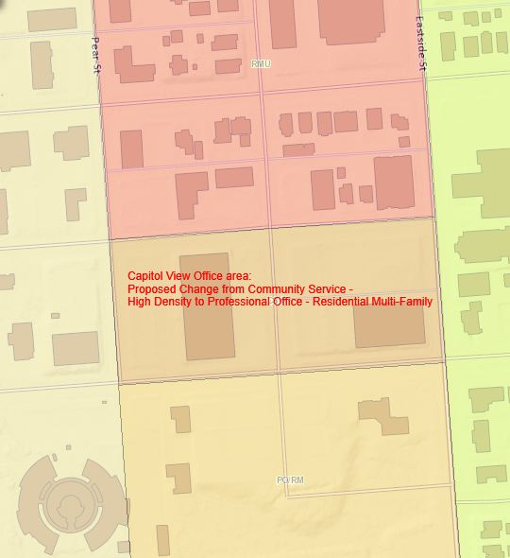
Current Land Use Zoning: Commercial Services – High Density (CS-H)

Being Considered: Change to Professional Office/Residential
Multi-family (PO/RM) zone

Why change? Commercial Services is a zone primarily applied to Capitol Campus – only two other properties in Olympia are in this zone. The City has no zoning authority on the State Campus – instead planning for the campus is done by State government. This has led the City to consider whether different zoning might be more appropriate for the two remaining privately-owned CS-H sites.

Options: Retain CS-H zoning; change to PO/RM zoning; or choose another zone (to date City staff have not identified a viable third option.) See next page for a basic comparison of the two zones.
New Future (long-term) Land Use designation for these two blocks being considered as part of the Comprehensive Plan update: “Professional Offices & Multifamily Housing. This designation accommodates a wide range of offices, services, limited retail uses specifically authorized by the applicable zoning district, and moderate-to-high density multifamily housing in structures as large as four stories.”

The zoning code describes the purpose of PO/RM as: “This district is intended to: provide a transitional area, buffering residential areas from more intensive commercial uses. Development within this district should be compatible with residential uses and generate a low vehicular traffic characteristic of less intrusive uses; and provide for a compatible mix of office, moderate- to high-density residential, and small-scale commercial uses, in order to provide opportunities for people to live, work, and recreate in a pedestrian-oriented area.”

Comments and questions regarding this proposal should be directed to Todd Stamm, Principal Planner, at city hall at 360.753.8597 or tstamm@ci.olympia.wa.us. Note that before any decisions are made, the Olympia Planning Commission would hold a public hearing and review the proposal – and any final decision would be made by the City Council.

TABLE 6.01 (EXCERPT) PERMITTED AND CONDITIONAL USES
CAPITOL VIEW COMPARISON
P=Permitted; C=Conditional Use (special approval required); Prohibited uses not listed
COMMERCIAL DISTRICT | CSH | PO/RM
1. EATING & DRINKING ESTABLISHMENTS
Drinking Establishments | C
Restaurants, without drive-in or drive-through | P | C
2. INDUSTRIAL USES
Publishing | C | C
Wholesale Sales |  | C
3. OFFICE USES (See also SERVICES, HEALTH)
Banks | P | P
Business Offices | P | P
Government Offices | P | P
4. RECREATION AND CULTURE
Art Galleries | P | P
Commercial Recreation |  | C
Health Fitness Centers and Dance Studios | P | P, maximum 5,000 sq.ft.
Libraries | P | C
Museums | P | C
Parks, Neighborhood | P | P
Parks & Playgrounds, Other | P | P
5. RESIDENTIAL
Apartments | P | P
Boarding Houses | P | P
Co-Housing |  | P
Duplexes | P | P
Fraternities, Dormitories | P | C
Group Homes (6 or less) | P | P
Group Homes (7 or more) | C | C
Retirement Homes | P | P
Single-Family Residences | P | P
Single Room Occupancy Units | P
Townhouses | P | P
6. RETAIL SALES
Commercial Greenhouses, Nurseries, Bulb Farms | C | C
Electric Vehicle Infrastructure | P | P
Food Stores | P | P; maximum 5,000 sq.ft.
General Merchandise Stores |  | P; maximum 5,000 sq.ft.
Office Supplies and Equipment | P | P, maximum 5,000 sq.ft.
Pharmacies and Medical Supply Stores | P | P, maximum 5,000 sq.ft.
Specialty Stores |  | P, maximum 5,000 sq.ft.
7. SERVICES, HEALTH
Hospitals | P
Nursing, Congregate Care, and Convalescence Homes | C | C
Offices, Medical | P | P
8. SERVICES, LODGING
Bed & Breakfast Houses  (1 guest room) |  | P
Bed & Breakfast Houses  (2 to 5 guest rooms) | C | P
Hotels/Motels | P
Lodging Houses | P | P
9. SERVICES, PERSONAL
Adult Day Care Home | P | P
Child Day Care Centers | P | P
Crisis Intervention | C | P
Family Child Care Homes | P | P
Funeral Parlors and Mortuaries |  | C
Laundries and Laundry Pick-up Agencies |  | P
Personal Services | P | P
10. SERVICES, MISCELLANEOUS
Printing, Commercial | P | P
Public Facilities (see also Public Facilities, Essential below) | P | C
Radio/T.V. Studios | P | P
Recycling Facilities | P | P
School - Colleges and Business, Vocational or Trade Schools | P | C
Servicing of Personal Apparel and Equipment |  | P
Workshops for Disabled People | C | C
11. PUBLIC FACILITIES, ESSENTIAL
Inpatient Facilities | C | C
Jails | C
Other Correctional Facilities | C | C
Other facilities as designated by the Washington State Office of Financial Management, except prisons and solid waste handling facilities |  | C
Radio/TV and Other Communication Towers and Antennas | C | C
Sewage Treatment Facilities | C | C
State Education Facilities | C | C
State or Regional Transportation Facilities | C | C
12. TEMPORARY USES
Off Site Contractor Offices | P | P
Emergency Housing | P | P
Mobile Sidewalk Vendors |  | P
Residences Rented for Social Event (6 or less in 1 year) | P | P
Residences Rented for Social Event (7 or more in 1 year) | C | C
Temporary Surface Parking Lot | P | P
13. OTHER USES
Agriculture | P | P
Animals | P | P
Cemeteries | C | C
Fraternal Organizations | P | P
Garage/Yard/Rummage and Other Outdoor Sales | P | P
Home Occupations | P | P
Parking Facility, Commercial |  | P
Places of Worship | C | C
Racing Pigeons | C | C
Satellite Earth Stations | P | P
Schools | C | C
Utility Facility | P/C | P/C
Wireless Communications Facilities | P/C | P/C

TABLE 6.02 (Excerpt) COMMERCIAL DISTRICTS’ DEVELOPMENT STANDARDS
CAPITOL VIEW COMPARISON
STANDARD | Commercial Services (CS-H) | Professional Office/Residential Multi-Family (PO/RM)
MINIMUM LOT SIZE | 7,200 Sq. Ft. if bldg. height is 35' or less.  12,500 Sq. Ft. if bldg. height is over 35'. | No minimum, except residential; 7,200 sq. ft. for apartments
FRONT YARD SETBACK | No minimum. | 10' minimum
REAR YARD SETBACK | 5' minimum if building has 1 or 2 stories.  10' minimum if building has 3 or more stories. | 10' minimum; Except next to an R 4, R 4-8, or R 6-12 district = 15' minimum + 5' for each bldg. floor above 2 stories.
SIDE YARD SETBACK | 5' minimum if building has 1 or 2 stories.  10' minimum if building has 3 or more stories; AND the sum of the 2 side yards shall be no less than 1/2 the building height. | No minimum on interior, 10' minimum on flanking street; Except:  Next to R 4, R 4-8, or R 6-12 district = 15' minimum + 5' for each building floor above 2 stories. Solely residential structures: 5'.
MAXIMUM BUILDING HEIGHT | 75' Exception: Up to 100' may be allowed with conditional approval by the City Council, upon recommendation of the Hearing Examiner. | Up to 35', if any portion of the building is within 100' of R 4, R 4-8, or R 6-12 district; up to 60' otherwise.
MAXIMUM BUILDING COVERAGE | No requirement. | 70%, except 55% for residential only structures
MAX. DEVELOPMENT COVERAGE | 100% | 85%, except 75% for residential only structures
ADDITIONAL DISTRICT-WIDE DEVELOPMENT STANDARDS | Residential uses must comply with High Rise Multi-family (RM-H zone) development standards. (See table 4.04 of Development Code.) | Building floors above 3 stories which abut a street or residential district must be stepped back a minimum of 8 feet.

